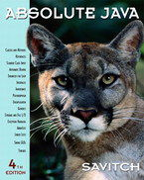 **COSC 1320**

**Name: _________________ Seat # __**

**Estimated Hours 1**

**Actual Hours**

**TA (Textual Analysis) for UML USE CASE Diagram MODEL**

**Programming Assignment 2:**

**(10 points)**

**(Due date found in the COSC 1320 BB Calendar!)**

**You must use Microsoft WORD program. Insert the TEMPLATEs for Actors and Use Cases in this Requirements Document.**

*Please have Step 1, 2, 3, and 4 in this order.*

PLEASE use the “TA for UML USE CASE Diagram MODEL Movie Company System.doc” AS TEMPLATE.

(Do not Show STEP 1,…; do not change Line Numbers; do not change Number of Pages)

Any DIAGRAM that is NOT the result of CUT and PASTE

WILL BE IGNORED. (YOU WILL GET ZERO POINTS)

**Requirements Analysis**: Construct the **UML USE CASE** Diagram MODEL

ProgrammingAssignment2 APPLICATION for ANIMATING an electrical CIRCUIT using SWING.

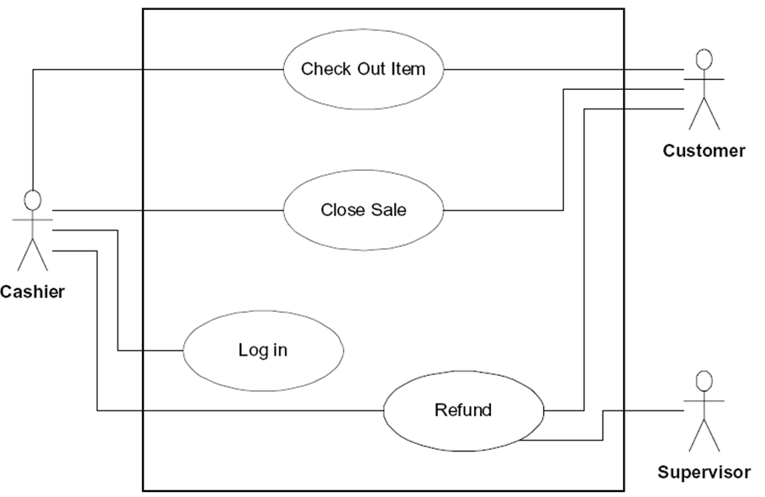Write an **application** that controls an electrical circuit that has a power source, a switch, and a light bulb. The user wants to control the names of the Labels, thus they must be read from a data file named “**Programming Assignment 2 Data.txt**”.

**A1: User**

A sample input file **“Programming Assignment 2 Data.txt”** follows:

Animation of an Electrical Circuit

Power Supply

Switch

Light bulb

You will have two buttons, labeled Open and Close. When you click on Close (see that the switch shows that it is closed - redraw) the light bulb should turn on. When you click on Open (see that the switch shows that it is open - redraw) the light bulb should turn off.

The title of your window must be “Programming Assignment 2”.

Create a **ProgrammingAssignment2.java** that contains the **main method**.

**JAVA** Exception Handling is also required.

**TA (Textual Analysis) for UML USE CASE Diagram MODEL**

**for Movie Company System**

**A1: User**



The **Movie Company** has the following affiliated Artists (maximum 10):

**“Miles Davis”, with 3 Discs:**

Disc 1: **Title** “Miles Ahead” with Track “Miles Ahead” that is 3.34 minutes

Disc 2: Title “Tutu with Tracks: “Tutu”, 4.56, “Portia”, 3.34, “Tomaas”, 3.56

Disc 3: Title “Kind of Blue” with Tracks “So What”, 4.54, “Freddie Freeloader, 5.25, “Blue in Green”, 2.56

**“John Coltrane”, with 1 Disc:**

Disc 1: Title “Blue Train” with Blue Train” that is 5.15 minutes; “Moments Notice”, 5.52, “Locomotion”, 6.18

The **Movie Company** wants to keep a **catalog** of its artists and their discs (maximum 30). **Artist**s have a name. The **Movie Company** can ***add an artist*** or get a ***listing of all its artists***.

UC2: **UCListArtists**

UC1: **UCAddArtist**

Each artist produces music **Disc**s. A Disc is associated with an Artist. A Disc is cataloged with a disc catalogNumber. The **Movie Company** can ***add a disc*** or get a ***listing of all its discs***.

UC4: **UCListDiscs**

UC3: **UCAddDisc**

A Disc has a number of **Track**s. The Track has a **title** and a duration **time**. A Disc has a catalogNumber , a title, the number of tracks. The **Movie Company** can ***add a track*** or get a ***listing of all tracks for a given disc***.

UC7: UC**RestoreCatalog**

UC8: UC**SaveCatalog**

UC6: **UCListTracksForDiscs**

UC5: **UCAddTrack**

A1: **User**



UCcloseGate

UCopenGate

UCreadFile

**Controller**

**UC 1**

**UC2**

**UC3**

**UC1** UCcloseGate **Description**

|  |  |
| --- | --- |
| **Name:** | UCcloseGate |
| **Actor:** | **User** |
| **Description:** | **This use case describes the process used by User to light the bulb** |
| **Successful Completion:** | **User clicks the closeButton**   1. **SwitchBoard calls actionPerformed(e) to check which button was clicked** 2. **If closeButton was clicked, bulb changes to YELLOW and successful message is sent to the User** |
| **Alternative:** | **User clicks the closeButton**   1. **SwitchBoard calls actionPerformed(e) to check which button was clicked** 2. **If Exception is thrown, nothing happens and unsuccessful message is sent to the User** |
| **Pre-Condition:** | **User clicks closeButton** |
| **Post-Condition:** | **Lightbulb changes color or not** |
| **Assumptions:** | **None** |

**UC2 UCListArtists Description**

|  |  |
| --- | --- |
| **Name:** | UCcloseGate |
| **Actor:** | **User** |
| **Description:** | **This use case describes the process used by User to turn off the bulb** |
| **Successful Completion:** | **User clicks the openButton**   1. **SwitchBoard calls actionPerformed(e) to check which button was clicked** 2. **If openButton was clicked, bulb changes to LIGHT_GRAY and successful message is sent to the User** |
| **Alternative:** | **User clicks the openButton**   1. **SwitchBoard calls actionPerformed(e) to check which button was clicked** 2. **If Exception is thrown, nothing happens and unsuccessful message is sent to the User** |
| **Pre-Condition:** | **User clicks openButton** |
| **Post-Condition:** | **Lightbulb changes color or not** |
| **Assumptions:** | **None** |

**UC3** UCreadFile **Description**

|  |  |
| --- | --- |
| **Name:** | UCreadFile |
| **Actor:** | **User** |
| **Description:** | **This use case describes the process used by User to provide names for the components** |
| **Successful Completion:** | **User requests adding user-defined labels to components** |
| **Alternative:** | **None** |
| **Pre-Condition:** | **User requests to provide names for the components** |
| **Post-Condition:** | **Names are assigned to sub-panels.** |
| **Assumptions:** | **None** |